PROGRAM

Danses Sacree et Profane Claude Debussy

Sophia Chuang, harp
from the studio of Elizabeth Ojeda

Meditation Julius Massnet
from Thais

Alisha Govindaraj, violin
from the studio of Janet Milnes
Alla Kuznetsov, piano

Papillons, Op. 1 no. 1-6 Robert Schumann

Aria Knechtges, piano
from the studio of Alla Kuznetsov

Intermezzo in E-flat Minor, Op. 118 no. 6 Johannes Brahms

George Daddis, piano
from the studio of Howard Spindler

French Suite No.3, BWV 814 J.S. Bach
Allemande

Howard Tang, piano
from the studio of Irina Lupines

Symphonie espagnole, Op. 21 Édouard Lalo
- Allegro non troppo

Ashley Park, violin
from the studio of Yoojin Jang
Na Young Koo, piano

Etude Tableux, Op. 39 no. 9 Sergei Rachmaninov

Ziyang Ye, piano
from the studio of Irina Lupines

Als Luisa die Briefe ihres W.A. Mozart
ungetreuen Liebhabers verbrannte

Meredith Hart, soprano
from the studio of Teresa Ringholz
Matthew Robey, piano

The Prophet Bird Robert Schumann

Randy Pollok, piano
from the studio of Howard Spindler

Scherzo in E Major, Op. 54 Frédéric Chopin

John Douglas Hanson, piano
from the studio of Patricia Hanson

Sonata Lawson Lunde
- Allegro vivace

Alex Wu, alto saxophone
from the studio of Chisato Eda Marling
Matthew Robey, piano

___________________________________________________ _

Howard Spindler, faculty chairperson
______________________________________________________

We acknowledge with respect the Seneca Nation, known as the “Great Hill People” and “Keepers of the Western Door” of the Haudenosaunee Confederacy. We take this opportunity to thank the people on whose ancestral lands the Eastman School of Music of the University of Rochester currently occupies in Rochester, New York.
Audience Guidelines
Out of respect for all the performers, we ask audience members to stay until the end of the recital. If an exception must be made (for example, small children may be unable to sit through a long program quietly), please enter and leave the hall only between performers.
Please ensure that children are quiet and remain seated.
www.esm.rochester.edu/community

ECMS Showcase Recital

Eighteenth Recital of the 2022-2023 School Year

Saturday, December 3, 2022
3:30 pm
Kilbourn Hall

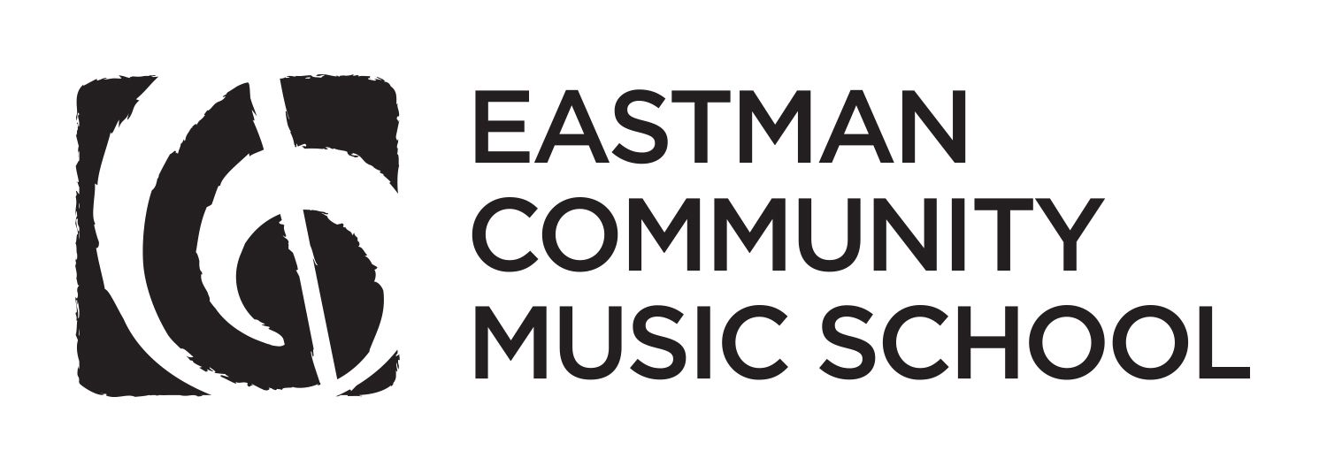
Eastman School of Music • University of Rochester

