**GOING TO HEAR A CONCERT AT / IN THE**

**________________________**

I am going with __________________________ to hear a concert at / in the _________________________!

|  |
| --- |
| **PHOTO OF VENUE / PERFORMANCE SPACE HERE** |

I am going on _____________________, 2025

The concert starts at ______ and ends at _____

Hearing a concert is like listening to music on a radio, a computer, or a sound system, except that people are right there in person playing music for an audience. They are called “musicians.”

Some concerts have music with singing, and some concerts have music with no words, like the music in a movie. The concert that I will hear presents a group of musicians playing music with no words. A piece written for a small group of musicians is called “chamber music.”

|  |
| --- |
| **CHAMBER GROUP PHOTO HERE** |

[NAME OF CHAMBER GROUP HERE] will play  
music with no words

The concert is at the ____(SPACE NAME)__________________ in ____(BUILDING NAME)_______________. I will follow instructions telling me and my friends where to go and where to sit.

|  |
| --- |
| **PHOTO OF VENUE / PERFORMANCE SPACE HERE**  **(SHOW SEATS / CHAIRS)** |

Before we go to our seat, I can ask to use the restrooms or drink some water. Then, I will wait until ____________________________ tells me where I can sit.

When we get to our seats, I will sit down nicely on a chair or in my wheelchair and   
wait for the concert to start. I can use fidget toys or other favorite things to keep me busy while I wait.

When it is time for the concert to start, the room will get slightly darker and [IF THAT’S THE CASE] everyone will get quiet. I will try to be as quiet as I can during the concert so that I can hear everything.

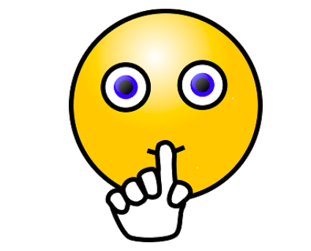

Before the musicians start playing, someone will say a few words about the music the musicians, and their instruments . Then the group of musicians will play. The musicians might have to tune their instruments first in order to sound just right!

|  |
| --- |
| **CHAMBER GROUP PHOTO HERE** |

While listening, I can sway my body with the music or conduct with my hands. I will try not to hum or sing along so that all my friends can hear the music.

If I feel afraid or nervous, I can cover my ears, hold ______________________’s hand, or hug _______________________.

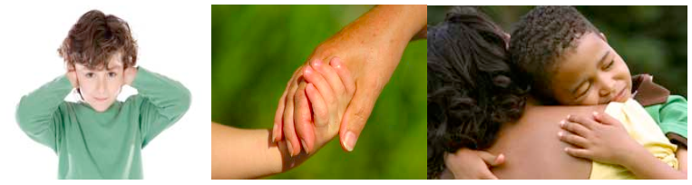

During the concert, some people will clap after each song.



Clapping is nice because it tells the musicians that you liked their song and music. If I want to clap, I can. I don’t have to clap if I don’t want to.

If the clapping is too loud, I can cover my ears, wear my headphones, or hold ______________________________’s hand.

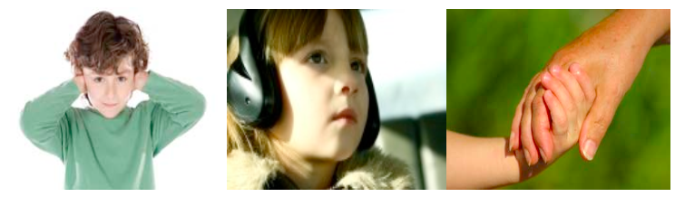

I know that even though the clapping can be loud and can feel scary, none of the noise can hurt me.

At the end of the performance, three people will be have a chance to ask one question each to the musicians. I will raise my hand or tell _______________________ if I want to ask a question.



After the concert is over, we will exit the ___________________ by using **good walking** and **inside voice**, and go back to ________________________.

I am very excited to go hear a concert at / in the __________________!

|  |
| --- |
| **PHOTO OF VENUE / PERFORMANCE SPACE HERE** |